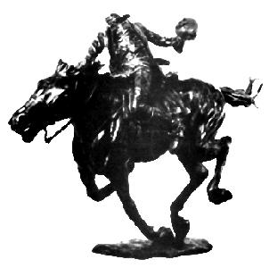

Village of Sleepy Hollow
BOARD OF TRUSTEES
Tuesday, February 10, 2026
Tentative Agenda / Subject to Change

- Pledge & Moment of Silence
- Public Hearings: Ban on Gas Powered Leaf Blowers, Loading Zone on Pocantico Street, Remote Meetings
- Approval of Warrant
- Minutes: 1/13/2026, 2/3/2026
- Mayor’s Announcements/Appointments
- Auditors Report
- Report – Public Works
- Public Comments

- Resolutions:
R1 – Accept Resignation from Police Officer
R2 – Home Rule Request for On-Street Permit Parking
R3 – Approve Feral Cat Agreement with the SPCA
R4 – Approve Seasonal Employee for the Parks Department
R5 – Approve Agreement with ASCAP
R6 – Approve School Resource Officer Agreement
R7 – Set Public Hearing on the Tax Cap
R8 – Approve IMA with the County Related to Electric Vehicle Chargers
R9 – Approve Electric Vehicle Charger Proposal
R10 – Set Public Hearing for Stop Signs on North Washington and Chestnut
R11 – Approve Actions of the Fire Warden

10) Old Business / New Business
11) Communications, Petitions & Requests
12) Public Comments
13) Adjournment

Executive Session at Call of the Mayor

